Rogene Worley Middle School Weekly Lesson Plan School Year 2018-19
Department: Elective- Spanish Grade Level: 8 Six Weeks: 4th Week: 2 Dates:1/14-18
100% Every Student, Every Day
Week 2 Lesson Plans
Key:
Items highlighted in yellow are paper copies.
Items highlighted in blue are power points. The Calentamiento powerpoint has dates and pre-made warm-ups. Feel free to edit or adjust.
Items highlighted in green are laminated/printed games/activities (located in blue bin under my desk),manipulatives or labels
If highlighted in violet, use the Así se dice 1 textbook and follow the instructions in the teacher’s edition. The textbook is blue and located on bookshelf in the back of the room.
- Part 1: En clase y después (school supplies and activities, clothing, -ar verbs in the present tense)
 | Monday | Tuesday | Wednesday
TEKS
ßDual Coding
Lesson Objective  (WE will learn)  Anticipatory Set | WRITE THESE ON THE BOARD EVERY DAY!  “We will review vocabulary about school and clothing items.” | “We will review vocabulary about school and clothing items.” | “We will learn how to use pronouns in Spanish.”
I will statement  Independent Practice | “I will participate in Kahoot and Matamoscas (Fly Swatter).” | “I will participate in Rally Coach and be assessed over my new vocabulary.” | “I will take cornell notes and participate in Rally Coach.”
Instruction:  Modeling  Guided Practice  Independent Practice | - Calentamiento (10)  - Kahoot (15) - My Kahoot login is in the sub binder if you need it!  https://play.kahoot.it/#/k/0e5237e9-db3f-4a3c-b016-522eff1252ad - Give the students about 3 minutes to join. They may pair up with someone, but can only get one prize per device being used.  I use the automated names option so that students don’t use inappropriate names. I suggest using the options below for the settings (zoom in if needed)  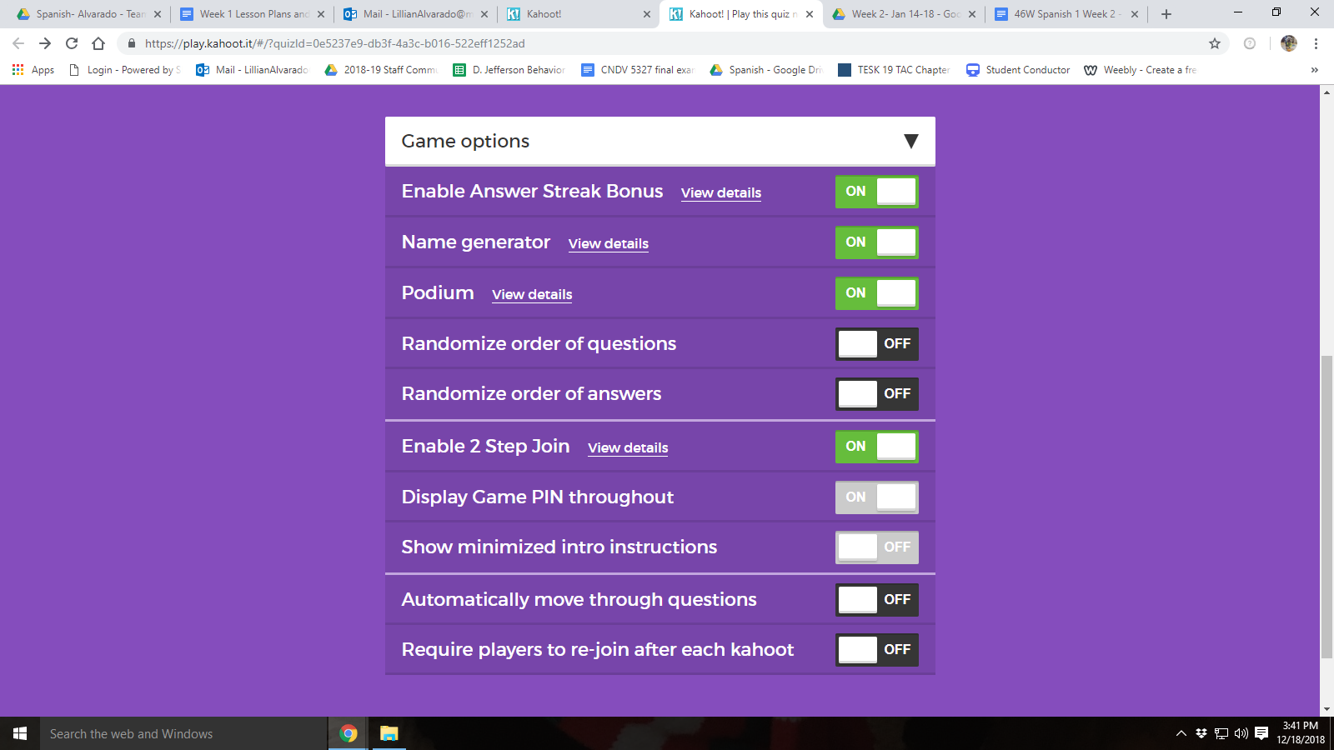  - Matamoscas (20)- (Use the master bingo card from last week if you are not sure what vocab words the pictures correspond to)  - Have the students spread the cards out, facing up across their and their partner’s desk (Each group gets one ziploc bag with cards). The you will randomly call the cards/vocab words out, and each student’s goal is to slap the card AFTER you ring the bell (located by my lotion), or count to 3, whatever is easier for you.  - Say the words in Spanish, and use them in the sentences if you would like.  - The partner with the most cards at the end is the winner. | - Calentamiento (10)  - Rally Coach- Whiteboard Activity (15)- My students have done this activity multiple times, so they should be familiar with it!  - Anytime we do rally coach, the students will need a whiteboard (at the top of their station bins), dry erase marker (can use their own or one of mine), and an eraser (located in the white rolling cart to the right of the board-please make sure they put materials back where they got them from at the end of the activity).  - Use the powerpoint named Rally Coach in the week 2 folder.  - The students take turns writing the answers on the powerpoint with a partner.  - They will raise their board up when they are done, and I usually say “muy bien” if they did it correctly, or “no” if they need to try again. Sometimes I count them off in Spanish so I can make sure everyone participates. Feel free to change it up to what is best for you.  - Vocabulary Quiz (20)- 2019 Spanish 1 Chapter 3A- La escuela y ropahttps://b.socrative.com/teacher/#import-quiz/32289178  - Students take their tests and quizzes on socrative, refer to my testing instructions in the sub binder.  - Make sure to make about 40 copies in advance for students that do not have a device, or students that need to make up the test due to absences.  - Students may re-take tests and quizzes for up to a 70. They must come in to tutoring on Thursdays or Friday mornings in order to do so (no later than 2 weeks after the assessment has been given). Quizzes count once under the daily work (DLY) category.  - Students may study vocabulary on Quizlet (Google Classroom), use devices, or read a book when they are done. You may change this if you’d like. | - Calentamiento (10)  - Pronouns video - Have students write 7 facts from the video in their journals, then share. (5)https://www.youtube.com/watch?v=vrLS5gaBaus  - Pronouns Cornell notes ppt- review. Make copies (185 copies) of the cornell notes hand-out beforehand. (15)  - Rally Coach- Pronouns practice- this activity is toward the end of the power point you used to have the students take notes (15)
Seed Question  FSGPT | “What are activities that we do during the school day?” | “What are activities that we do during the school day?” | “How are pronouns used in the present tense?”
AVID  strategy |  |  | Cornell Notes
Kagan / lead4ward Strategy |  | Rally Coach | Rally Coach

Rogene Worley Middle School Weekly Lesson Plan School Year
Department: Grade Level: Six Weeks: Week: Dates:
100% Every Student Every Day
 | Thursday | Friday | Notes
TEKS  Dual Coding | 1A, B, C | 1A, B, C
Lesson Objective  (WE will)  Anticipatory Set | “We will learn how to change -ar verbs in the present tense.” | “We will be able to conjugate -AR Spanish verbs in the present tense.”
I will statement  Independent Practice | “I will take cornell notes and complete an exit ticket.” | “I will conjugate -ar verbs during present tense drills and will participate in un minuto loco.”
Instruction:  Modeling  Guided Practice  Independent Practice | - Calentamiento (10)  - CNOTES EL presente regular (-ar)  Introduce the Present Tense (You will use the same Power Point for the next 4 activities)  - Present Tense Gramactiva video- show to students (5) https://drive.google.com/file/d/19UcCvJA21J271nLliJldSAqPH1s0fbrq/view?usp=sharing  - CNOTES El presente regular- give each student a copy of the notes handout(20)  - Practice (5) | I. Calentamiento (10)  II. Present tense drills- Rally Coach(15)  III. Song Part 1-(10) Instructions and Extra Credit- https://docs.google.com/presentation/d/1aP43X6Ls04S3Ss-iQtL3izVlMoj4YxUOwYoV0mmqW9k/edit#slide=id.p3  Song Video- https://www.youtube.com/watch?v=1RuevxWIoCM  - Have the students watch the video for the song  - Show the words on the power point, and learn the first half of the song today.  IV. Talk about Extra credit (10)  V. Tres minutos locos- partnered activity (10)  - Make copies of hand-outs and cut in half to separate the activities.  - Use the powerpoint titled TRES MINUTOS LOCOS for instructions. Feel free to change it up to whatever is easier for you and the students.
Seed Question  FSGPT | “How are pronouns used in the present tense?” | “How do I conjugate -ar verbs in the present tense?”
AVID Strategy |  | Cornell Notes
Kagan Strategy |  | Graffiti

